Machine learning

Introduction
- Machine learning is a set of algorithms that help transform data into management actions by learning from past data. Machines are more accurate than humans, less bias, faster, and it is cheaper to repeatedly use machines once algorithms are developed.
  - Inaccurate or insufficient data will make machine learning algorithms worse than humans in any of these categories
Machine learning algorithms can be grouped by their learning styles:
- Supervised learning: input data has observations that have known labels e.g. positive or negative. A model makes predictions based on the features of observations, then extrapolates this model to new data sets
  - Examples include classifications of patients into risk categories based on data, using regression to predict sales volume from advertising spend, kNN algorithms
- Unsupervised learning: input data is not labelled; the aim is to define labels for observations. Model deduces structures present in the data through a mathematical process to systematically reduce redundancy, or by organising data by similarity.
  - Examples problems are clustering, dimensionality reduction and association rule learning. Examples of algorithms include neural networks, k-means algorithms
- Semi-supervised learning: input data is a mix of labelled and unlabelled observations
- Reinforcement learning specifies

Introduction of AI
- Agrawal, Gans and Goldfarb – an economic explanation of the success of AI is that machine learning algorithms allow use to make cheap prediction about the future. Easier and faster predictions enable faster and more intelligent decisions.
- Authors propose a pyramid structure to build AI capabilities and competitive advantages.
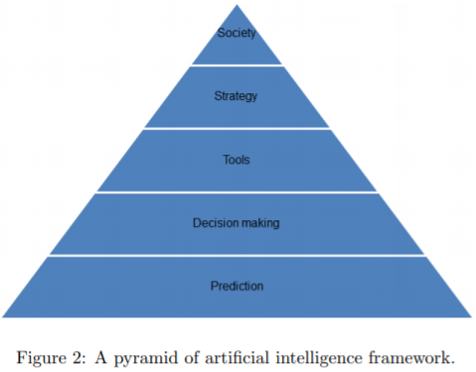
  - Insufficient to have smart analytical tools, need strategies to keep them to allow AI to work, e.g. strong leadership on top, willing champions at the bottom, company-wide culture, effective platforms for data storage and analysis

- They also propose a canvas to demonstrate how to decompose larger decisions
  - Action – what are you trying to do
  - Prediction – what do you need to do to make decisions
  - Judgement – how are different outcomes and errors evaluated
  - Outcome – metrics for task success
  - Input – data needed to run predictive algorithms
  - Training – data needed to train predictive algorithms
  - Feedback – how can outcomes improve the algorithms

K-nearest neighbour algorithm

